**Intelligent Waste Sorting System**

**Group Members**

1. Kidusan Bihon Akele
2. Eyob Tesfaye
3. Biruk Kassaye
4. Nahom Keneni
5. Yeabsira Bekele Rorissa

**Table of Contents**

Concept Note 1

Project Overview 1

Objectives 1

Background 1

Methodology 2

System Architecture 2

Data Sources 3

Literature Review 3

Implementation Plan 3

Technology Stack 3

Development Timeline 4

Team Structure 4

Key Milestones 4

Challenges and Mitigations 4

Ethical Considerations 5

Evaluation Metrics 5

References 6

**List of Figures**

Figure 1: System Architecture ………………………………………………………3

Figure 2 : Gantt Chart for Intelligent Waste Sorting System………………………...5

# **Concept Note**

## Project Overview

The Intelligent Waste Classification System addresses critical environmental challenges by developing a smartphone-based solution for accurate waste sorting. This project directly supports SDG 12 (Responsible Consumption and Production) by improving recycling efficiency through artificial intelligence. Current waste management systems suffer from inefficient manual sorting (25-30% error rates) and high costs of automated industrial solutions. Our mobile approach leverages the smartphone's camera and processing capabilities to provide an accessible, cost-effective alternative that achieves >85% classification accuracy. The potential impact includes increased recycling rates, reduced contamination in waste streams, and democratized access to smart waste management technology.

## Objectives

The project has four primary objectives:

* Develop a lightweight CNN model achieving >85% accuracy on waste classification.
* Create an Android application with real-time camera-based classification.
* Implement an offline-first architecture with cloud synchronization.
* Design an educational interface that promotes sustainable disposal practices.

## Background

Modern waste management faces significant challenges in sorting efficiency, with only 9% of plastic waste being recycled globally. While existing solutions like IoT-enabled smart bins (Kumar et al., 2019) and industrial sorting robots (Nowakowski & Pamuła, 2020) show promise, they remain inaccessible to most communities due to high costs. Our solution bridges this gap by utilizing smartphone capabilities - 84% of the global population owns a mobile device, making this the most scalable approach. The system builds upon proven CNN architectures while overcoming hardware limitations through model optimization techniques.

## Methodology

The implementation follows a structured machine learning pipeline:

* **Data Preparation:** Using the TrashNet dataset (2,500+ images across 6 categories) supplemented with Kaggle Waste Classification data.
* **Model Development:** Transfer learning with MobileNetV3, followed by quantization for mobile deployment.
* **Mobile Integration:** Android app development using CameraX API and TensorFlow Lite.
* **Evaluation:** Testing across different mobile device generations to ensure compatibility.

## System Architecture

The architecture comprises three core components:

* **Mobile Client:** Handles image capture and real-time inference (Samsung device).
* **ML Model:** 8MB quantized TensorFlow Lite model for waste classification.
* **Cloud Backend:** Firebase for anonymous usage analytics and model updates.

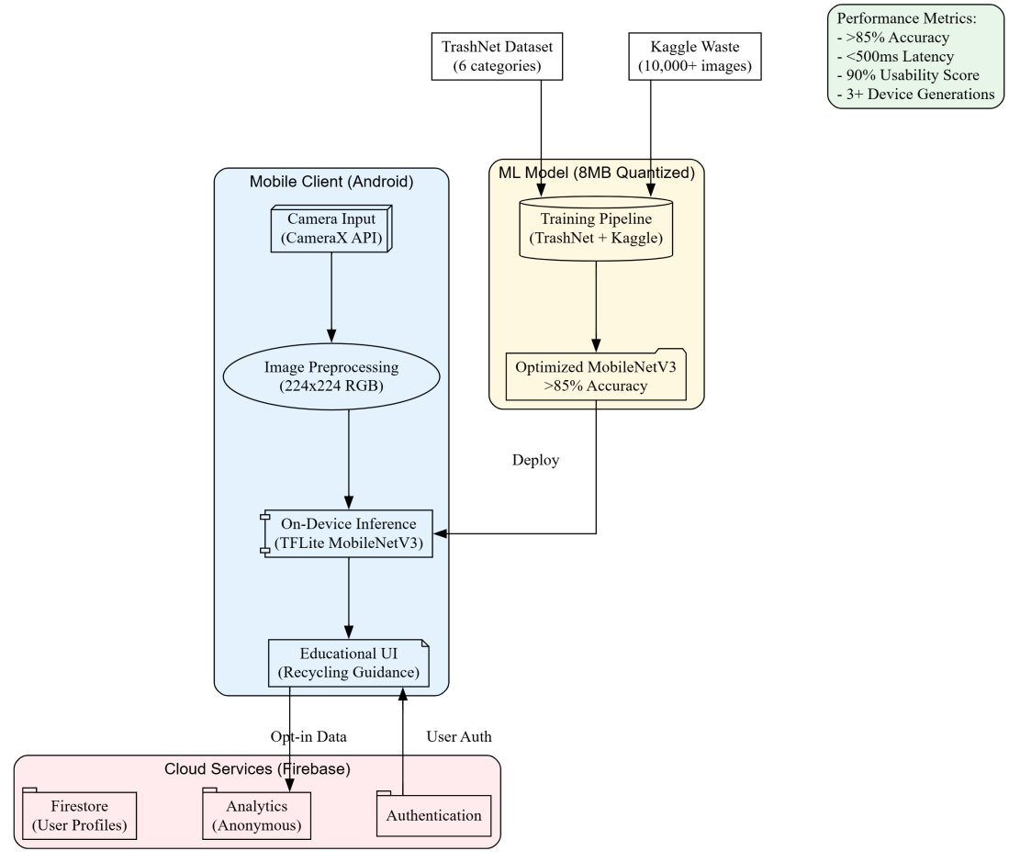

***Figure 1: System Architecture***

## Data Sources

The primary dataset is TrashNet (Yang & Thung, 2016), containing 2,500+ high-resolution waste images across six categories (paper, plastic, metal, glass, cardboard, and trash). This is supplemented with 10,000+ images from Kaggle's Waste Classification dataset to improve generalizability. All images undergo mobile-specific preprocessing including resizing to 224x224px and normalization for optimal on-device performance.

## Literature Review

Existing research demonstrates CNNs' effectiveness in waste classification (92% accuracy - Mittal et al., 2020) and IoT's cost-reduction benefits (30% savings - Anagnostopoulos et al., 2017). Our project innovates by combining these approaches in a mobile context, addressing the scalability limitations of previous solutions. The literature confirms that while industrial systems achieve high accuracy, smartphone-based implementations can maintain >85% accuracy with proper optimization (Google ML Kit, 2023).

# Implementation Plan

## Technology Stack

The project utilizes:

* **Core ML:** TensorFlow Lite, MobileNetV3
* **Mobile Development:** Android Studio (Flutter), CameraX API
* **Cloud Services:** Firebase Authentication, Firestore
* **Supporting Tools:** Google Colab (model training), Git (version control)

## Development Timeline

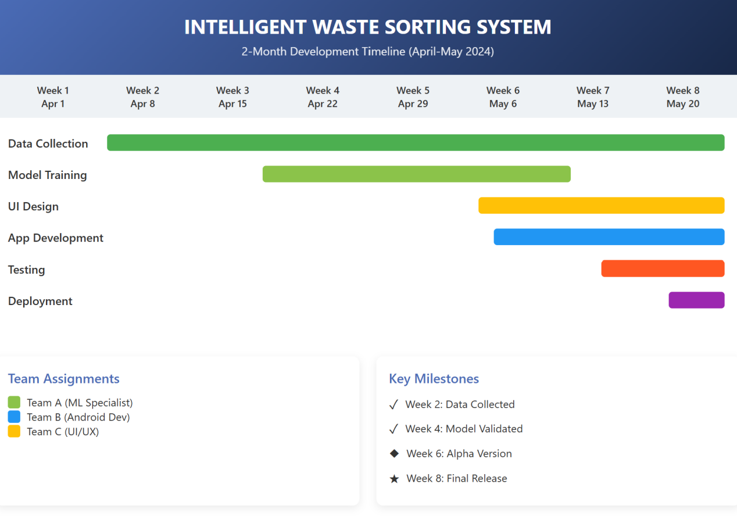

***Figure 2 : Gantt Chart for Intelligent Waste Sorting System***

## Team Structure

* **ML Specialist:** Model development and optimization
* **Android Developer:** Core application implementation
* **UI/UX Designer:** Interface and user experience
* **Cloud Engineer:** Firebase integration
* **Testing Coordinator:** Quality assurance and field testing

## Key Milestones

* **Milestone 1:** - Data collection finalized
* **Milestone 2:** 2,500+ images processed

## Challenges and Mitigations

The project addresses three core technical challenges with adaptable solutions. For model size reduction, the ML Specialist will apply FP16 quantization to shrink the TensorFlow Lite model to 8MB, initially testing on mid-range Samsung A-series devices. To optimize camera performance, the Android Developer will implement frame-skipping algorithms and buffer management, focusing on devices with full Camera2 API support. Regarding device compatibility, the Testing Coordinator will validate performance across a diverse pool including budget, popular, and stock Android devices running Android 10+. This flexible approach ensures broad accessibility while allowing for targeted optimizations based on real-world test data.

## Ethical Considerations

The implementation addresses three key ethical concerns:

* **Privacy Protection:** All processing occurs on-device with optional cloud sync
* **Bias Mitigation:** Dataset augmentation ensures balanced representation
* **Digital Inclusion:** Support for mid-range devices

## Evaluation Metrics

Success will be measured by:

* **Accuracy:** >85% on validation set
* **Latency:** <500ms inference time
* **Usability:** 90% task completion in user tests
* **Compatibility:** Support multiple platforms

# References

* Yang, M., & Thung, G. (2016). Classification of Trash for Recyclability Status. (Waste Management)
* Mittal, G., et al. (2020). A Deep Learning Approach to Detect and Classify Waste. (IEEE Access)
* Google (2023). On-Device ML Best Practices. (ML Kit Documentation)